**Maryann Jordan contributions**

**data.js**

**Retrieve 2 chicago traffic apis using ajax and json**

**Design database structure**

**Insert data into cameras firebase database; update data if over a day old**

**About.html (instructions for using app)**

**Index.html (highlight mode and lighten submit button color for usability)**

**Help debugging**

**QUERY FOR CHICAGO API RED LIGHT CAMERA**

<https://data.cityofchicago.org/api/views/thvf-6diy/rows.json?accessType=DOWNLOAD>

**JSON DATA FOR CHICAGO API RED LIGHT CAMERA**

// Sample JSON DATA

// Red Light obj[0][5944

// Red Light obj[1]"0B7DA671-A671-40C7-8F73-C9B0F5A392A1"

// Red Light obj[2]5944

// Red Light obj[3]1414553253

// Red Light obj[4]"878752"

// Red Light obj[5]1414553253

// Red Light obj[6]"878752"

// Red Light obj[7]null

// Red Light obj[8]"Pulaski-Diversey"

// Red Light obj[9]"SB"

// Red Light obj[10]"NB"

// Red Light obj[11]null

// Red Light obj[12]"2009-05-15T00:00:00"

// Red Light obj[13]"41.931791"

// Red Light obj[14]"-87.726979"

// Red Light obj[15]["{\"address\":\"\"

// Red Light obj[16]\"city\":\"\"

// Red Light obj[17]\"state\":\"\"

// Red Light obj[18]\"zip\":\"\"}"

// Red Light obj[19]"41.931791"

// Red Light obj[20]"-87.726979"

// Red Light obj[21]null

// Red Light obj[22]false]]

**QUERY FOR CHICAGO API SPEED CAMERA**

<https://data.cityofchicago.org/api/views/4i42-qv3h/rows.json?accessType=DOWNLOAD>

**JSON DATA FOR CHICAGO API SPEED CAMERA**

// Sample JSON DATA

// speed obj[0][4658

// speed obj[1]"5CC304FE-0F80-448D-AFAC-24F3789F20B0"

// speed obj[2]4658

// speed obj[3]1427253157

// speed obj[4]"878752"

// speed obj[5]1427253157

// speed obj[6]"878752"

// speed obj[7]null

// speed obj[8]"3843 W 111th (Speed Camera)"

// speed obj[9]"EB"

// speed obj[10]"WB"

// speed obj[11]"01/13/2014"

// speed obj[12]"41.69120239624487"

// speed obj[13]"-87.71721139909997"

// speed obj[14]["{\"address\":\"\"

// speed obj[15]\"city\":\"\"

// speed obj[16]\"state\":\"\"

// speed obj[17]\"zip\":\"\"}"

// speed obj[18]"41.69120239624487"

// speed obj[19]"-87.71721139909997"

// speed obj[20]null

// speed obj[21]false]]

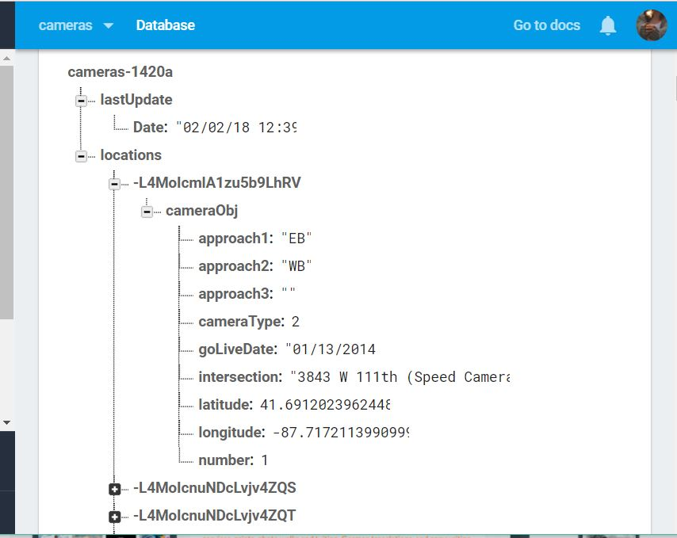

**DATABASE STRUCTURE**

**DATA.JS (Maryann Jordan) Notes**

Data.js creates the database and updates if the update/date is over a day old.

required

<script src="https://cdnjs.cloudflare.com/ajax/libs/jquery/3.2.1/jquery.min.js"></script>

<script src="https://cdn.jsdelivr.net/momentjs/2.12.0/moment.min.js"></script>

<script src="https://www.gstatic.com/firebasejs/4.9.0/firebase.js"></script>

CHICAGO coordinates

Latitude‎: ‎41.881832

Longitude‎: ‎-87.623177

**database notes:**

locations

approach1: approach1 is 1st camera direction (string)

approach2: approach2 is 2nd camera direction (string)

approach3: approach3 is 3rd camera direction (string)

cameraType: 1=Redlight 2=speed (number)

goLiveDate: goLiveDate date camera went live (date MM/DD/YYYY)

intersection: intersecting streets (string)

latitude: location (float)

longitude: location (float)

number: incrementing number

lastUpdate

Date: date of update (must be a string MM/DD/YYYY hh:mm)

(firebase wants string date or its own timestamp)

**Sample data for speed camera**

locations

approach1: "SB"

approach2: "null"

approach3: ""

cameraType: 2

goLiveDate: "01/04/2014"

intersection: "4436 N Western (Speed Camera)"

latitude: 41.9624218495406

longitude: -87.68886227502836

number: 189